WATER SUPPLY MANAGEMENT SYSTEM

**INTRODUCTION**

System is based on work for water supplier companies that maintain their client profile and record based upon date. Company register with system then through login based system it can securely login and create client whiten that company can securely save the record, update or delete. The client account created by companies can be assessed

**Intended Audience**

This version is intended for company and its clients. We stand ready to support the product and help you to make the most of it. We welcome theme and module developers to play with this release and start turning out slick new designs for our happy users. If you have questions or problems, you can get help in the Gallery forums:

**Supported Configuration**

Platform: Browser.

Web server: Apache 2.2 and newer.

PHP Laravel v8 or greater.

Database: MySQL 5 and newer.

For complete system requirements, please refer to: 03343874070

**Installing and Upgrading Instructions**

**Create a database with name Jetstream**

**Write php artisan migrate:fresh in command line**

**you’re good to go**

**Detailed Interface Design**

The idea for design was to make its design simple that its user interface should be user friendly.

After studying design interface of many university portals our idea of an outcome was decided by my team to make a template that was simply. The layout will be consisting of three sections of template

**Homepage**

**Home page is where a user can view all registered companies with their location and information including their clients.**

**Company can register or login**

**Client can login only**

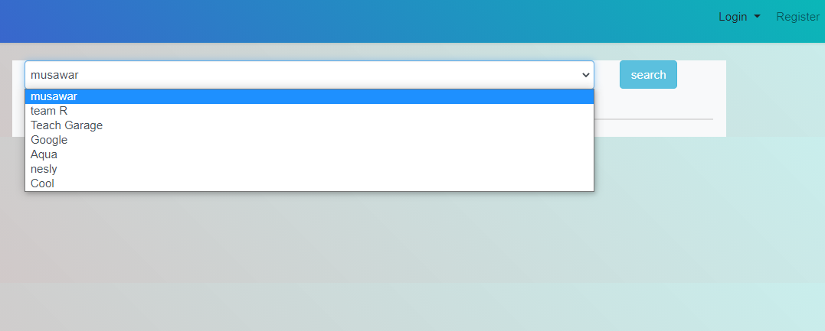

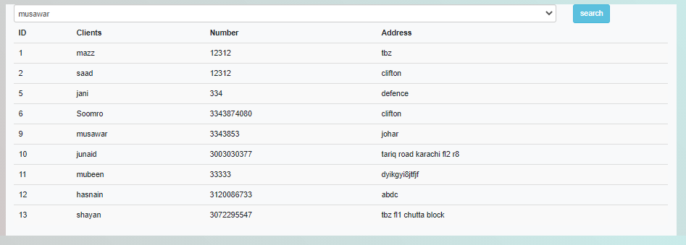

**Company Register Page**

**This is where a company can register itself/**

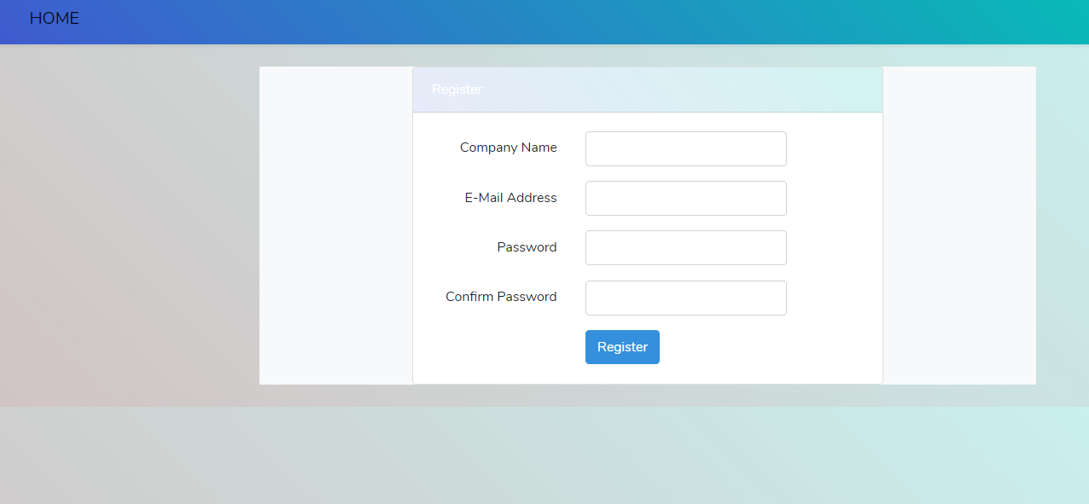

**Login Page For Company**

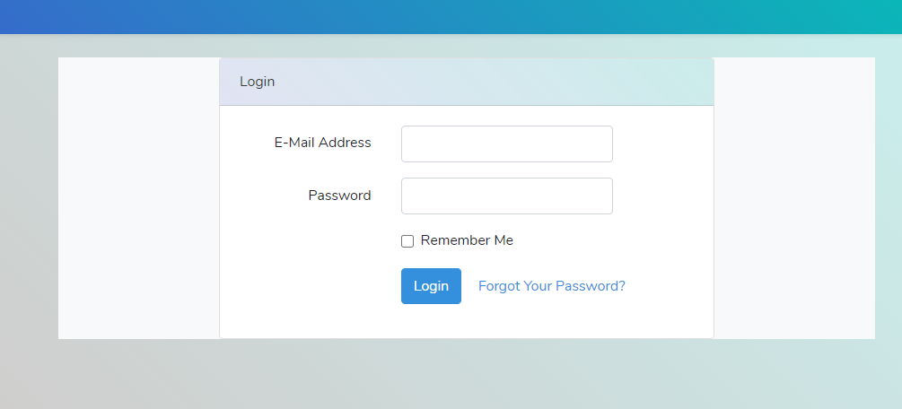

**Reset** **Page**

In case user forget their password

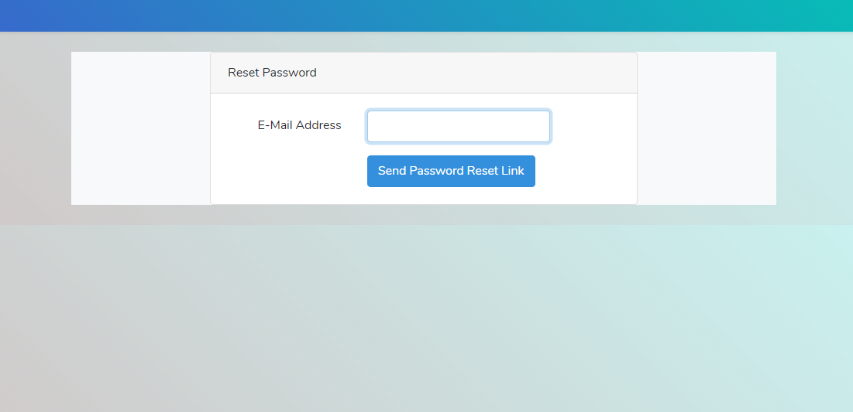

**After Company login**

Company can create client, view all clients set there status, Edit or Delete

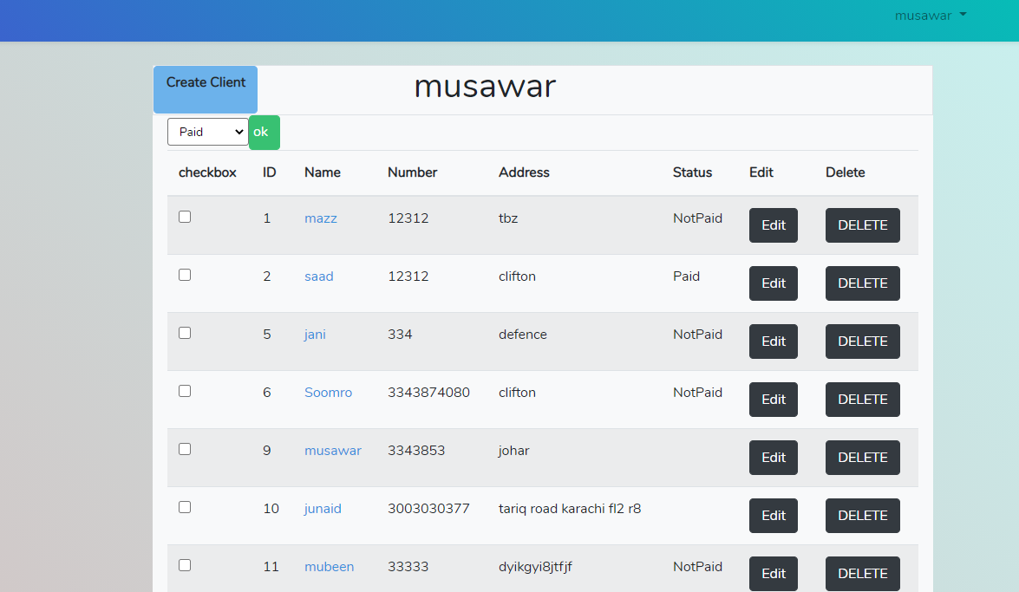

**Create Client**

Create client information where an auto generate password is set for client login and for company to set the record

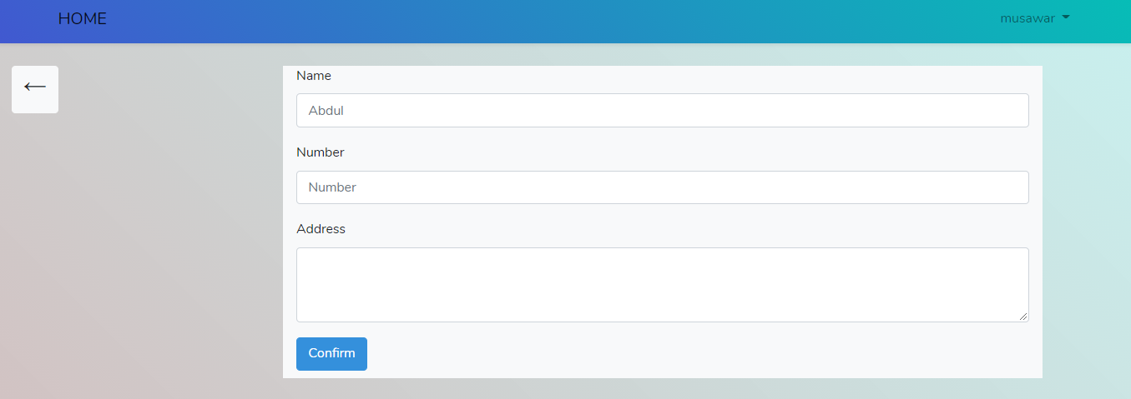

**Client** **Record**

On this page record based on year and month is recorded, Moreover record can be set for every year and month view or delete.

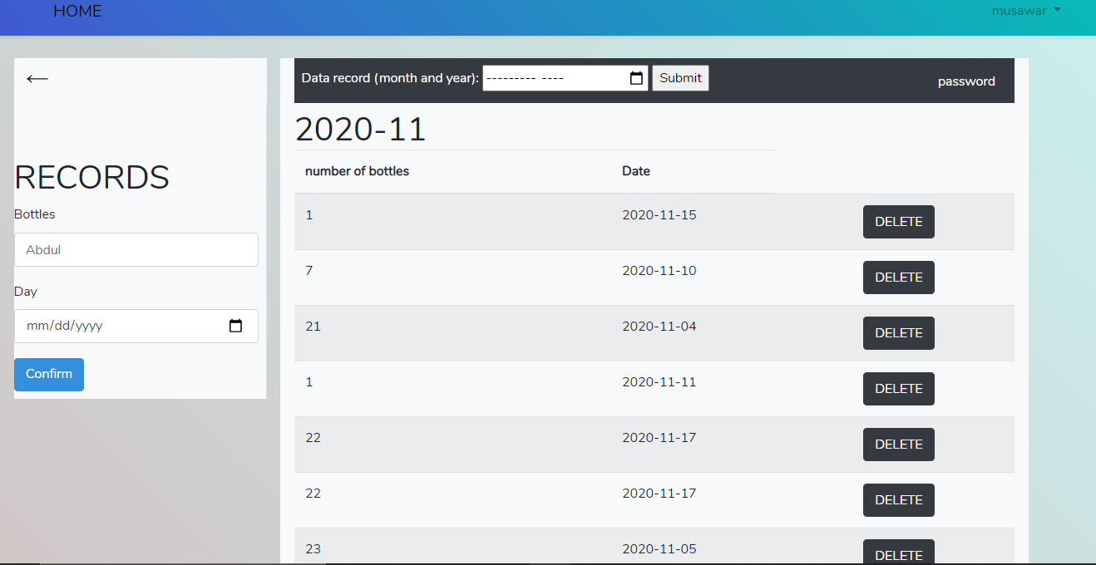

**Records**

Where records for user are set

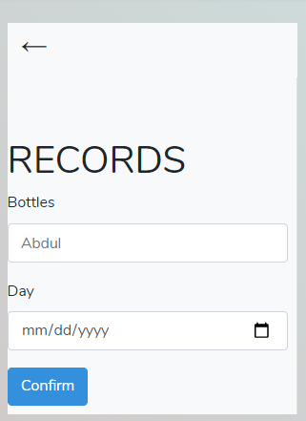

**Date**

Every date record is viewed through this section from selecting years then month

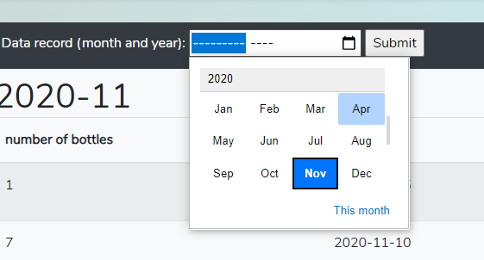 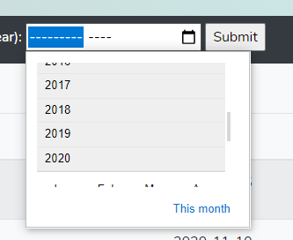

Client password can be viewed through password button where a popup window will show

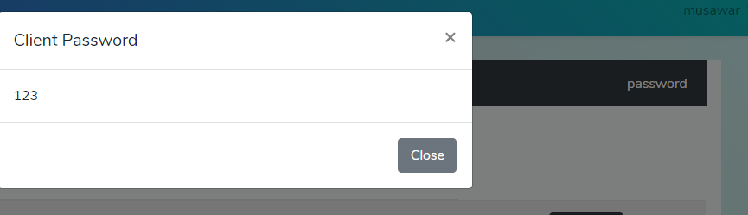

**Login through client**

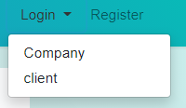

Client can login through their mobile number and password provided by company

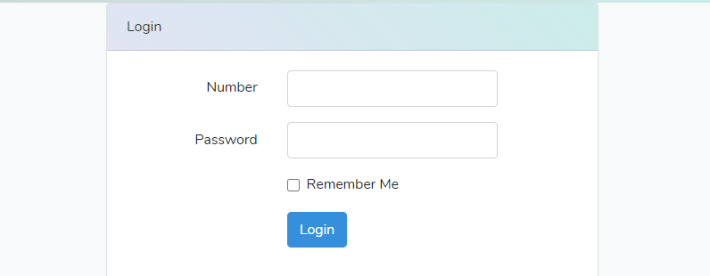

There monthly record can be seen with number of bottles they bought

